John Bell CS295N Term Project Proposal

Summary
A simple CRM for businesses to maintain a list of existing customers or leads and ensure follow up with each of them.

Specific Goals
Business user should be able to:
- View the next customer or leads to contact in a list based on how long it has been since they were last contacted.
- View all customers or leads.
- Add Notes to customer or lead listings.
- Notify the system that they have contacted that customer or lead.
- Leave notes on customer or lead listings.
- Add customers and leads to a database.
- Remove customers or leads from the database.

Required Systems (Webpages)
- Home Page -- Displays simple explanatory text as well as the next customer and lead that needs to be contacted.
- View All Customers or Leads Page – Displays a lost of leads, include drop down selection that saves the selection via session, also include a search field by last name.
- Customer/Lead Details page – displays the information for the customer or lead, allows the user to add notes or mark that they have contacted the user, notes should save regardless of selection.
- Edit Customer Page – allow the user to edit the customer or leads contact information, or delete the user.
- Add customers or leads to the database.

Organization
- Home Page
  - Display General Information
  - Display customer with longest time since contacted
  - Link to Search
    - Shows all customers in alphabetical order by default, allows filtering.
    - Link to View Details
      - Link to Edit Customer
      - Delete Customer
      - Update Note
      - Mark as Contacted
  - Link to Add Customer

Customer Class
CUSTOMER
ID
firstName
lastName
streetAddress
city
state
zipCode
customerType(customer or lead)
notes
lastContact

Storyboards
Home Page
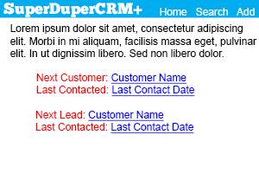
Search / View All Page
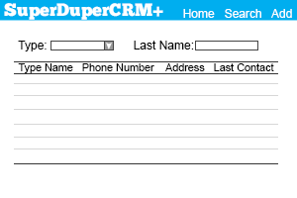

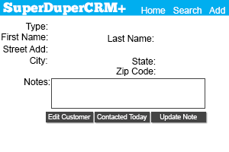
View Details Page
Edit Details Page / Add Customer Page (Will be same design for both, aside from buttons)
